|  |  |
| --- | --- |
| Morris Transit | Transit Passes, cash on board |
| Transit Alternatives | Cash on board (exact change), punch pass |
| Tri-Cap | Cash on board, tokens purchased from a vendor (grocery store, bank, city hall, etc) |
| CCT | Cash on board, punch passes |
| Prairie Five | Cash on board, punch car, monthly pass |
| United Community Transit | Cash on board, monthly pass, tokens |

Veterans ride free?

**Create payment_agency table with all payment methods for all agencies**

Cash on board the transit vehicle

Free rides through a social service

Monthly pass for unlimited rides

Punch card on board the transit vehicle, purchased from a vendor ahead of time

Tokens on board the transit vehicle, purchased from a vendor ahead of time

Tri-Cap Transit Connection

Stearns, Sherburne, Mile Lacs, Benton, Morrison

United Community Transit

Lincoln, Lyon, Redwood, Pipestone, Murray, Cottonwood, Rock, Jackson

City of Morris Transit

Stevens, Pope, Douglas, Grant, Traverse, Todd

None of the above

Central Community Transit (CCT)

Kandiyohi, Meeker, Renville

Transit Alternatives (Productive Alternatives, The Otter Express)

Clay, Wilkin, Otter Tail

Prairie Five Rides

Big Stone, Swift, Chippewa, Lac qui Parle, Yellow Medicine

(filtering only responses where transit agency and zipcode match)

SELECT *, ST_GeometryFromText('Point('|| locationlongitude || ' ' || locationlatitude || ')',4326)

FROM feb26data

WHERE q1 = 'Yes' AND q20 IN (SELECT CAST(zipcode as integer)

FROM agency_zip

WHERE agency = q2)

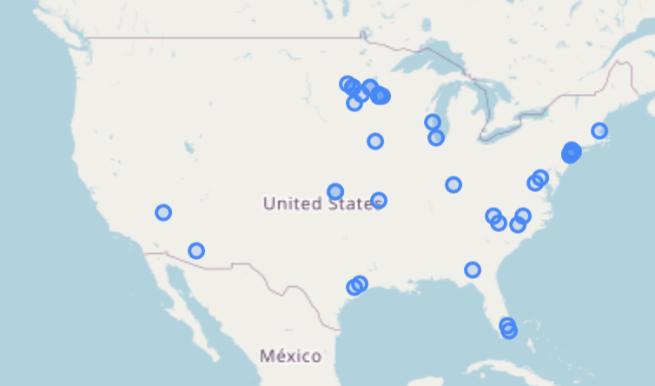

(filtering only responses where transit agency matches fare payment)

SELECT *, ST_GeometryFromText('Point('|| locationlongitude || ' ' || locationlatitude || ')',4326)

FROM feb26data

WHERE q1 = 'Yes'

AND q9 IN (SELECT fare_method

FROM agency_payment

WHERE agency = q2)

AND q20 IN (SELECT CAST(zipcode as integer)

FROM agency_zip)

(filtering both matches) – 27 total

SELECT *, ST_GeometryFromText('Point('|| locationlongitude || ' ' || locationlatitude || ')',4326)

FROM feb26data

WHERE q1 = 'Yes'

AND q9 IN (SELECT fare_method

FROM agency_payment

WHERE agency = q2)

AND q20 IN (SELECT CAST(zipcode as integer)

FROM agency_zip

WHERE agency = q2)

(MN zip codes, fare match)

SELECT *, ST_GeometryFromText('Point('|| locationlongitude || ' ' || locationlatitude || ')',4326)

FROM feb26data

WHERE q1 = 'Yes'

AND q9 IN (SELECT fare_method

FROM agency_payment

WHERE agency = q2)

AND q20 IN (SELECT CAST(geoid20 as integer)

FROM mn_zipcodes)

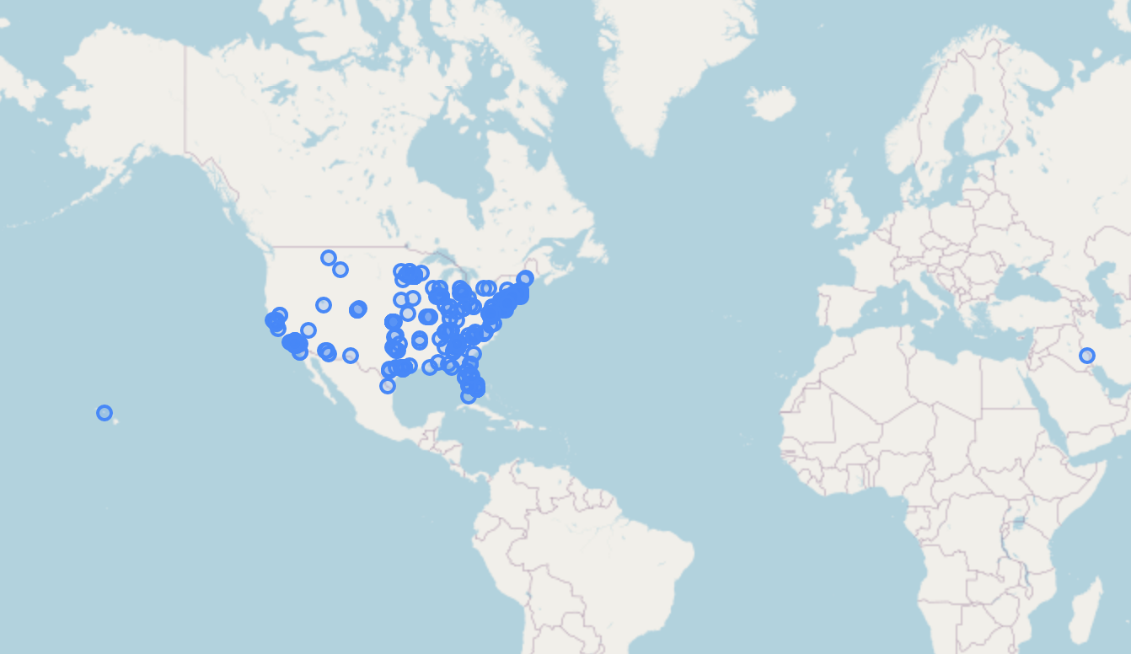

(just mn zip codes)

SELECT *, ST_GeometryFromText('Point('|| locationlongitude || ' ' || locationlatitude || ')',4326)

FROM feb26data

WHERE q1 = 'Yes' AND q20 IN (SELECT CAST(geoid20 as integer)

FROM mn_zipcodes)

(just service area codes)

SELECT *, ST_GeometryFromText('Point('|| locationlongitude || ' ' || locationlatitude || ')',4326)

FROM feb26data

WHERE q1 = 'Yes' AND q20 IN (SELECT CAST(zipcode as integer)

FROM studyarea_county_zip)

(identifying identical responses) (narrows down to 179 repeat responses, 42 in MN zipcodes, 17 in study area with all 613-618 duration)

WITH repeatResponses as

(SELECT DISTINCT duration_sec,q2,q3,q4,q5,q6,q7,q8,q9,q10,q11,q12,q13,q14,

q15,q16,q17_1,q17_2,q17_3,q17_4,q18,q19,q21,q22,q23,q24,COUNT(1),

CONCAT(duration_sec,q2,q3,q4,q5,q6,q7,q8,q9,q10,q11,q12,q13,q14,

q15,q16,q17_1,q17_2,q17_3,q17_4,q18,q19,q21,q22,q23,q24) as identifier

FROM feb26data

WHERE q1 = 'Yes'

GROUP BY duration_sec,q2,q3,q4,q5,q6,q7,q8,q9,q10,q11,q12,q13,q14,q15,q16,q17_1,q17_2,q17_3,q17_4,q18,q19,q21,q22,q23,q24

ORDER BY COUNT(1) DESC

LIMIT 53)

SELECT *

FROM feb26data

WHERE CONCAT(duration_sec,q2,q3,q4,q5,q6,q7,q8,q9,q10,q11,q12,q13,q14,

q15,q16,q17_1,q17_2,q17_3,q17_4,q18,q19,q21,q22,q23,q24) IN (SELECT identifier FROM repeatResponses)

Only unique response (743)

WITH repeatResponses as

(SELECT DISTINCT duration_sec,q2,q3,q4,q5,q6,q7,q8,q9,q10,q11,q12,q13,q14,

q15,q16,q17_1,q17_2,q17_3,q17_4,q18,q19,q21,q22,q23,q24,COUNT(1),

CONCAT(duration_sec,q2,q3,q4,q5,q6,q7,q8,q9,q10,q11,q12,q13,q14,

q15,q16,q17_1,q17_2,q17_3,q17_4,q18,q19,q21,q22,q23,q24) as identifier

FROM feb26data

WHERE q1 = 'Yes'

GROUP BY duration_sec,q2,q3,q4,q5,q6,q7,q8,q9,q10,q11,q12,q13,q14,q15,q16,q17_1,q17_2,q17_3,q17_4,q18,q19,q21,q22,q23,q24

ORDER BY COUNT(1) DESC

LIMIT 53)

SELECT *,ST_GeometryFromText('Point('|| locationlongitude || ' ' || locationlatitude || ')',4326)

FROM feb26data

WHERE CONCAT(duration_sec,q2,q3,q4,q5,q6,q7,q8,q9,q10,q11,q12,q13,q14,

q15,q16,q17_1,q17_2,q17_3,q17_4,q18,q19,q21,q22,q23,q24) NOT IN (SELECT identifier FROM repeatResponses)

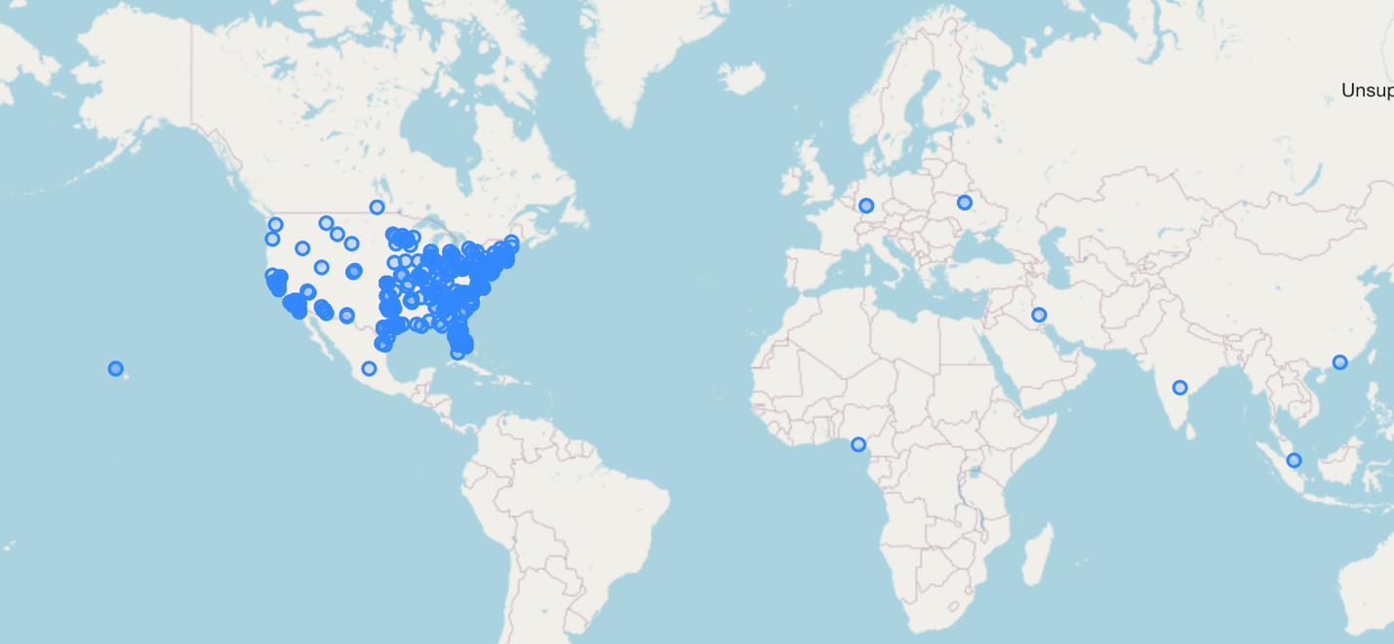

(nonidentifcal responses, MN zip code only, 497)

WITH repeatResponses as

(SELECT DISTINCT duration_sec,q2,q3,q4,q5,q6,q7,q8,q9,q10,q11,q12,q13,q14,

q15,q16,q17_1,q17_2,q17_3,q17_4,q18,q19,q21,q22,q23,q24,COUNT(1),

CONCAT(duration_sec,q2,q3,q4,q5,q6,q7,q8,q9,q10,q11,q12,q13,q14,

q15,q16,q17_1,q17_2,q17_3,q17_4,q18,q19,q21,q22,q23,q24) as identifier

FROM feb26data

WHERE q1 = 'Yes'

GROUP BY duration_sec,q2,q3,q4,q5,q6,q7,q8,q9,q10,q11,q12,q13,q14,q15,q16,q17_1,q17_2,q17_3,q17_4,q18,q19,q21,q22,q23,q24

ORDER BY COUNT(1) DESC

LIMIT 53)

SELECT *,ST_GeometryFromText('Point('|| locationlongitude || ' ' || locationlatitude || ')',4326)

FROM feb26data

WHERE CONCAT(duration_sec,q2,q3,q4,q5,q6,q7,q8,q9,q10,q11,q12,q13,q14,

q15,q16,q17_1,q17_2,q17_3,q17_4,q18,q19,q21,q22,q23,q24) NOT IN (SELECT identifier FROM repeatResponses)

AND q20 IN (SELECT CAST(geoid20 as integer)

FROM mn_zipcodes)

(nonidentical responses, service area zip code only, 143)

WITH repeatResponses as

(SELECT DISTINCT duration_sec,q2,q3,q4,q5,q6,q7,q8,q9,q10,q11,q12,q13,q14,

q15,q16,q17_1,q17_2,q17_3,q17_4,q18,q19,q21,q22,q23,q24,COUNT(1),

CONCAT(duration_sec,q2,q3,q4,q5,q6,q7,q8,q9,q10,q11,q12,q13,q14,

q15,q16,q17_1,q17_2,q17_3,q17_4,q18,q19,q21,q22,q23,q24) as identifier

FROM feb26data

WHERE q1 = 'Yes'

GROUP BY duration_sec,q2,q3,q4,q5,q6,q7,q8,q9,q10,q11,q12,q13,q14,q15,q16,q17_1,q17_2,q17_3,q17_4,q18,q19,q21,q22,q23,q24

ORDER BY COUNT(1) DESC

LIMIT 53)

SELECT *,ST_GeometryFromText('Point('|| locationlongitude || ' ' || locationlatitude || ')',4326)

FROM feb26data

WHERE CONCAT(duration_sec,q2,q3,q4,q5,q6,q7,q8,q9,q10,q11,q12,q13,q14,

q15,q16,q17_1,q17_2,q17_3,q17_4,q18,q19,q21,q22,q23,q24) NOT IN (SELECT identifier FROM repeatResponses)

AND q20 IN (SELECT CAST(zipcode as integer)

FROM studyarea_county_zip)

Q3,Q4 before, during

Q4,Q5 during, now

Q5,Q6 current, desired

Q3,Q5 before, now

Q8, Q9, Q10, Q11, Q18,